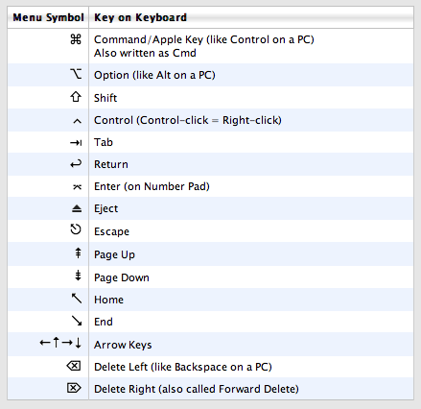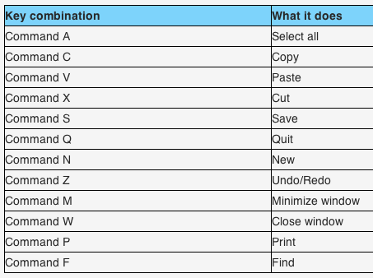Basic Mac OS X Shortcuts

<http://www.danrodney.com/mac/index.html>

<http://www.digitaltrends.com/computing/mac-os-x-keyboard-shortcuts/2/>